BALTIMORE VIRGINIA TECH ALUMNI
SCHOLARSHIP COMMITTEE, INC.
P. O. Box 6667
Ellicott City, Maryland 21042
(410) 442-2040

It is our pleasure to announce the availability of scholarship aid to students who have been accepted to attend Virginia Polytechnic Institute & State University (popularly known as Virginia Tech) matriculating each Fall. Our Committee funds one or more $2,500+ scholarships toward tuition annually. We invite scholarship applications from superior students who have been accepted to Virginia Tech and who meet the following criteria:

(1) be a U.S. Citizen, resident in either Baltimore City, Anne Arundel (north of Route 100), Baltimore, Carroll, Harford, or Howard Counties;
(2) accepted for admission at Virginia Tech as either a new or transfer student; and
(3) submission by pre-paid US Postal Service First Class Mail prior to the postmark deadline date of May 1, of a completed application including a current official transcript with all high school grades received to date, and such other brief credentials as may be necessary. All materials must be submitted under the same cover. Applications are not accepted prior to April 1st as it is usually to the student’s advantage to have as many 3rd quarter senior grades in as possible. Criteria and the above instructions will be STRICTLY enforced. No UPS or Fed Ex accepted.

The Board of Governors has full discretion to make this award, however, the Board does not discriminate based on race, color, creed, sex, or religion. Neither need nor area of study is a criteria in the Board’s determination of a scholarship winner. Selection is based upon: (1) academic merit, i.e. grades, class standing, and college entrance test scores (SAT, etc.), and (2) character, i.e., extracurricular school and community activities, leadership, responsibility and references. An interview may be conducted at Board discretion to determine the winner among finalists.

Eligible students are to forward their application packages between April 1st and May 1st BY US MAIL ONLY to the Committee at:

Baltimore VA Tech Alumni Scholarship Committee, Inc.
c/o. Barry W. Casanova, Esq.
P. O. Box 6667
Ellicott City, MD 21042

Any updates of information and/or applications will be posted at the Baltimore Virginia Tech Alumni Chapter’s Website: https://baltimore.vt.alumnispaces.com. The Board will endeavor to notify winners by June 1st. Note, only winners will be notified.

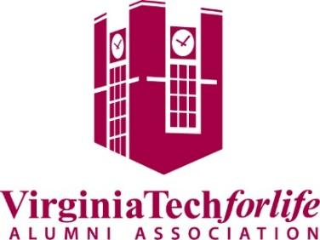
Please refer any questions to the Board of Governors Chairman, Barry Casanova, at (410) 442-2040.

